THE RISE OF FASCISM IN ITALY

NOTES:

Elements of Fascism:

- The individual should distrust reason and simply obey.
- Denial of equality – the strong have an obligation to destroy the weak.
- Violence is an essential tool.
- Government by an elite as the average person in incapable.
- Totalitarian – total state control of the lives of the individuals.
- Racism and Imperialism justified in that certain nations are elite and are obligated to control.
- Permanent mobilization – soldier valued above all other citizens.
- Anything is justified if it serves the state’s ends.
- Fascism emphasizes victory, glorifies war, is cruel to the weak, and is irrational and intolerant.
- By providing a uniform, someone to blame, someone to hate and a leader, fascism restores self-respect.

Fascism in Italy: Background

- Post WW I, Italy was intensely dissatisfied with her efforts in the war and the “spoils” she was awarded by the treaties.
- After the war, the economy was chaotic, the government was corrupt, and there was no order.
- “When times are bad, extreme political viewpoints become attractive.”

Benito Mussolini:

NOTES:

- After actually being a Socialist for a while, Mussolini switched his views and started the Fascisti Party.
- Skilled use of Fascist tools to gain some support – parades, propaganda, great speeches.
- Mussolini appealed to ex-servicemen, students, the middle class and to all anti-Communists.

The March on Rome – 1922

- Mussolini’s Black shirts began a march on Rome to gain power, as the Prime minister has refused to allow the Fascists into government.
- This created a threat of Civil War.
- King Victor Emmanuelle feared a civil war, and offered the government to Mussolini to avoid this.
- So, Mussolini took power with relatively little bloodshed.
- By 1925, Italy was a Totalitarian state, ruled by a Fascist dictator, with all personal freedoms abolished, and all opposition eliminated.

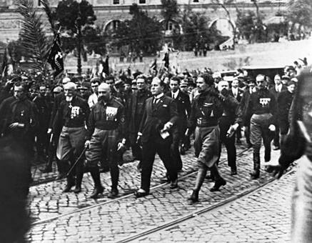

In February 1923, Mussolini and the Fascist Grand Council introduced the Acerbo Law. This law changed election results. Now if one party got just 25% (or more) of the votes cast in an election, they would get 66% of the seats in parliament.

NOTES:

* The Corporate State emerged – the economic plan for Italy

The Lateran Accords: - 1929

- Mussolini concludes a treaty with the Pope and the Catholic church
- The Vatican would remain the domain of the Pope (had previously lost Papal estates).
- Catholicism would be declared the only state religion, and a compulsory school subject.
- Not en element of fascism, but what are you going to do with a country that is 95% Catholic?

Fascist Imperialism:

- Italy had a small number of overseas colonies (3) and wanted more.
- Mussolini declared the Mediterranean Sea as “Mare Nostrum” (our sea).
- This would obviously threaten Britain and France’s trade routes.
- To show his newly found power, Mussolini decides to invade Ethiopia in 1935.
- Emperor Selassie appeals to the League of Nations, but gets no support.
- It takes the Italian army of mechanized equipment 3 weeks to defeat the Ethiopian army of horsebacks and turn of the century swords and rifles.

- The British and French decide to appease Mussolini through the Hoare-Laval Plan

NOTES:
- This meant “take half, leave half.”
- The League had imposed economic sanctions on Italy, but the USA was not a member, and kept supplying Italy with Oil and Steel.
- Italian fascism: First to rise and the first to fall!

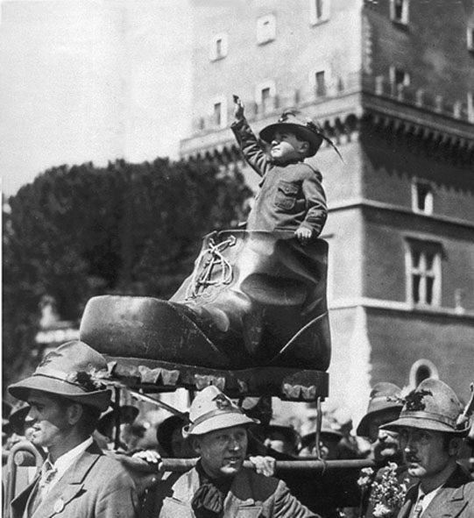

THE RISE OF HITLER – GERMAN FASCISM

NOTES:

The Rise of Adolf Hitler
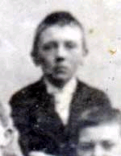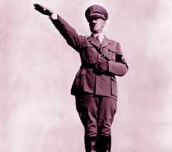

- Fact: Hitler was actually Austrian.
- Served in WW I and was awarded medals for combat
- Became very angry about the conditions of the Treaty of Versailles.
- 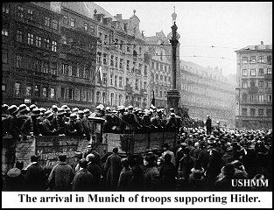Did not believe the Weimar Republic would have any success.

Organized the Beer Hall Putsch of 1923 – also called the Munich Putsch.

http://www.youtube.com/watch?v=DvD8bbCiAVE&feature=fvw – beer hall putsch

NOTES:
- The Beer Hall Putsch was a failure due to lack of support, Hitler was jailed for one year where he wrote Mein Kampf, a book which outlined his racial beliefs and his future for Germany.

In his book Hitler divides humans into categories based on physical appearance, establishing higher and lower orders, or types of humans. At the top, according to Hitler, is the Germanic man with his fair skin, blond hair and blue eyes. Hitler refers to this type of person as an Aryan. He asserts the Aryan is the supreme form of human, or master race.

• Once out of jail, Hitler forms the NSDAP – the National Socialist German Workers Party – NAZI’S
• His program denounced Versailles, Communists, Jews and the Weimar Government.
• Organizes them under military lines – uniforms, the Swastika, the SA (brown shirts)Hitler goes on to say that subjugated peoples actually benefit by being conquered because they come in contact with and learn from the superior Aryans. However, he adds they benefit only as long the Aryan remains absolute master and doesn't mingle or inter-marry with inferior conquered peoples.

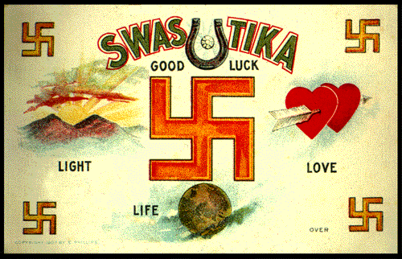But it is the Jews, Hitler says, who are engaged in a conspiracy to keep this master race from assuming its rightful position as rulers of the world, by tainting its racial and cultural purity and even inventing forms of government in which the Aryan comes to believe in equality and fails to recognize his racial superiority.

NOTES:
"The mightiest counterpart to the Aryan is represented by the Jew."

- Once out of jail, Hitler forms the NSDAP – the National Socialist German Workers Party – NAZI’S
- His program denounced Versailles, Communists, Jews and the Weimar Government.
- Organizes them under military lines – uniforms, the Swastika, the SA (brown shirts) and the SS (secret police).

Leader of the SA, Ernst Rohm.

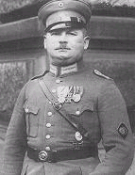
- Hitler then organizes an intensely nationalist program: to be used when he attains power:
- Unite all Germans in a common state.
- Cancellation of Versailles treaty and reparations.
- Regain Germany’s lost colonies.
- Full-scale rearmament.

These ideas appealed to many, including the wealthy because it produced pride and patriotism and was an alternative to Communism.

- 1926 sees the first appearance of the Hitler Youth.

NOTES:

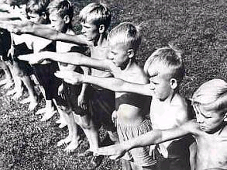By 1928, Hitler had 100,000 Nazi’s giving unconditional obedience to ‘Der Furher.’

Hitler seizes power:

- The Nazi Party gradually increased its numbers in the Reichstag (German Parliament) between 1928-33.
- 1928 – Nazi’s held 12 seats
- 1929 – World wide depression – “when times are bad, extremist political views sound good.”
- 1929 – Nazi’s won 107 seats.
- Why the gain? Middle class feared unemployment and Communism – small landowners feared tariff and trade policies of the Weimar – some people saw no alternative.
- 1932 – 5 million Germans unemployed – Depression brought about a split in the coalition governments. Hitler promised jobs.
- 1932 – Allies stop collecting reparations – too late.
- 1932 – Presidents Von Hindenburg puts Von Pappen in as Chancellor.
- 1932 – Nazi’s win 230 seats – Hitler demands to be next Chancellor.
- Another election, Nazi’s drop to 196 seats and the Communists win 100 seats.

NOTES:
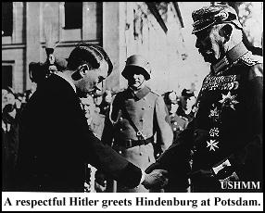Von Pappen and Hindenburg decide to give Chancellor to Hitler because they believe they could control him.

- Feb 1933 – Hitler calls for another election – the SA and the SS organize terror and intimidation in the streets.
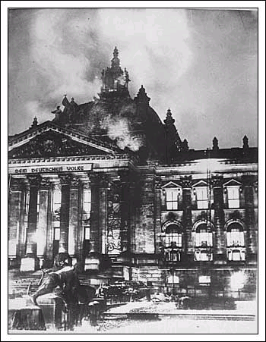Feb 27, 1933 – the Burning of the Reichstag – done by Hitler, but he blamed it on the Communists to create fear of a Communist revolution

http://www.youtube.com/watch?v=kOO2jTLFq8w&feature=related

- Election results – 17 million votes for the Nazi’s and a majority in government. http://www.youtube.com/watch?v=uAUPt9SX2qk&feature=related

- Hitler then uses his available Emergency powers to bring in the ENABLING ACT in March 1933.
This would give Hitler full dictatorial powers for 4 years, he then combined the positions of Chancellor and President when Hindenburg died in 1934 and became sole dictator of the German Reich.

NOTES:

Hitler in Power:
- Appealed to emotion (cruelty, pride, greed and envy) rather than reason.
- Master race – Concept of German superiority.
- Anti-Semitism – Persecution of the Jews, put the blame on them.
- The Nuremberg Laws 1934 – Laws restricting Jews in society
- The Final Solution: total elimination of the Jews – policy to be enacted in full force later. Not until 1942
- Scapegoats: Jews and Communists to be blamed for everything.
- Lebensraum: Hitler’s concept of “living space” for all Germanic peoples.
- The Night of the Long Knives: 1934 – Hitler needed to support of the German Army. The army did not trust the SA (brown shirts) under the command of Ernst Rohm. They did not see Rohm as being anything other than a thug. So Hitler arranged the murder of Rohm, who had helped Hitler come to power, and the dissolving of the SA. With this act, Hitler now had the support of the German Army, and made the SS and the Gestapo, under the command of Himmler, his personal army.

NOTES:
- Propaganda: total control of the radio, and the press to inundate the minds of the German population. Movies made by the government, with Nazi directors. All things geared towards the state. Gobbles in charge of this.
All economic resources channeled to war production with Goering in charge.

http://www.youtube.com/watch?v=W0eyxlRGo5Y

Crystal Night - 1938

During Crystal Night over 7,500 Jewish shops were destroyed and 400 synagogues were burnt down. Ninety-one Jews were killed and an estimated 20,000 were sent to concentration camps. Up until this time these camps had been mainly for political prisoners. The only people who were punished for the crimes committed on Crystal Night were members of the Sturm Abteilung (SA) who had raped Jewish women (they had broken the Nuremberg Laws on sexual intercourse between Aryans and Jews).
