The Treaty of Versailles
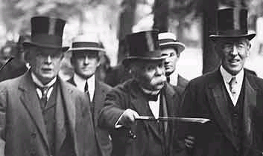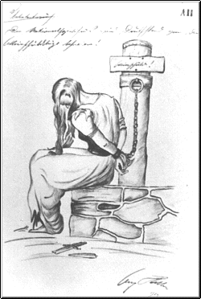The Paris Peace Conferences

The main points of the Treaty [BRAT]
1. Germany had to accept the Blame for starting the war (Clause 231).
2. Germany had to pay £6,600 million (called Reparations) for the damage done during the war.
3. Germany was forbidden to have submarines or an air force. She could have a navy of only six battleships, and an Army of just 100,000 men. In addition, Germany was not allowed to place any troops in the Rhineland, the strip of land, 50 miles wide, next to France.
4. Germany lost Territory (land) in Europe (see map, below). Germany’s colonies were given to Britain and France.

(Also, Germany was forbidden to join the League of Nations, or unite with Austria.)

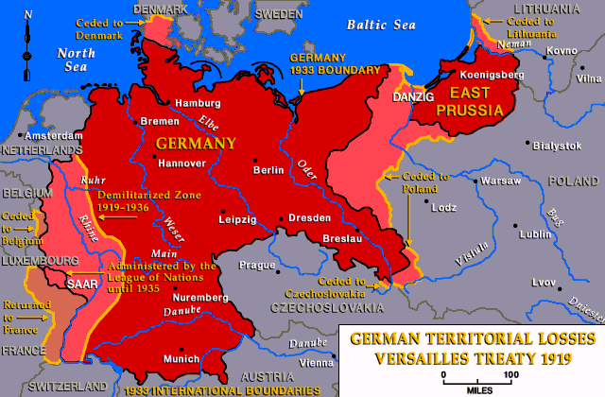

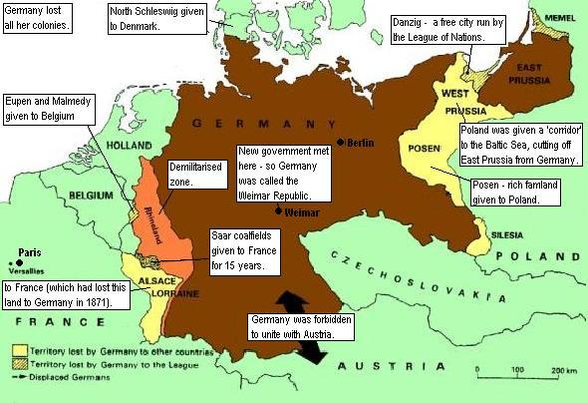
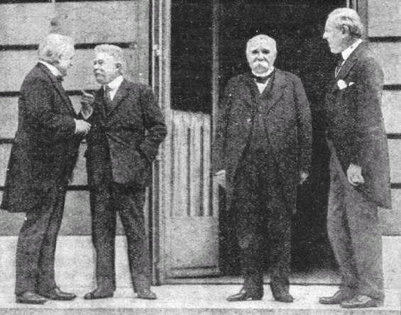
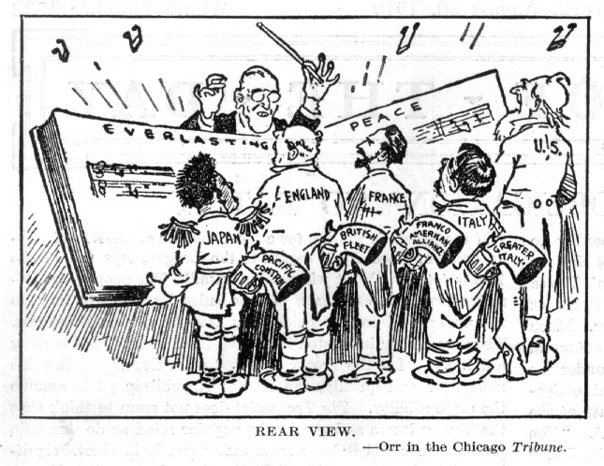
The German reaction to the Treaty of Versailles?

The consequences of Versailles?

Were the terms of the Treaty of Versailles actually carried out?
